Give Us Signs - Branding
“An introduction to semiotic analysis?”
What’s in a title?
Allow me to suggest that “semiotics is a reflective practice about signs”.
Reading images and texts is an essential to analysing signs.
The sign says:
“I am a sign”;
“I am a text”; and
“I am an image”.
We analyse signs by considering what they are and what they may stand for.
“A signifier has more than one signified and meaning changes according to a sequence. Furthermore, what is referred to can be represented by more than one sign. Circumstances impact upon the selection of texts and the emergence of meaning.”
Who analyses signs?
The “Prof” and the professional analyse signs. They analyse existing texts and create new ones. They are involved in a recycling; one that is referred to as bricolage.

Doors…
As quoted in an Oliver Stone movie about a band, a group of people playing music:
“There are things known
and there are things unknown
and in between are
the [d/D]oors”.

(Bunnings advertisement, Perth WA, 2007)

(Bunnings advertisement, Perth WA, 2007)
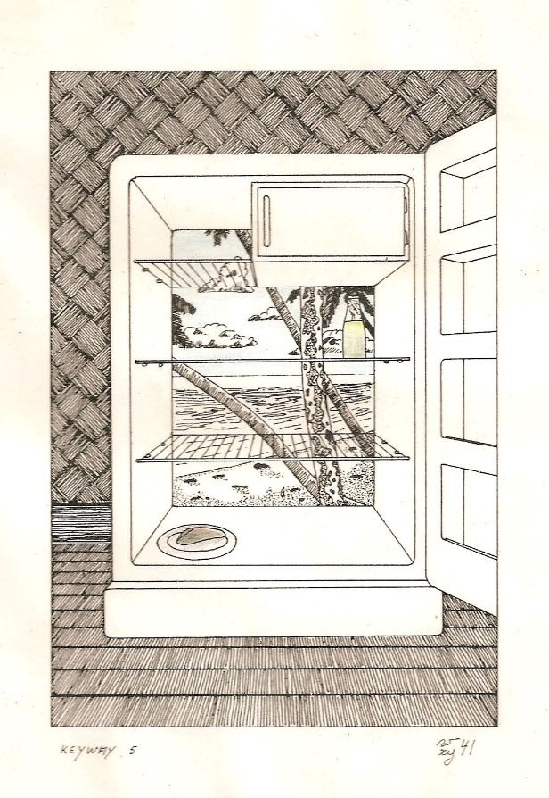

(Pierre Van Osselaer. “Keyway 5”.
Print, ink, and colour pencil. 1986.)

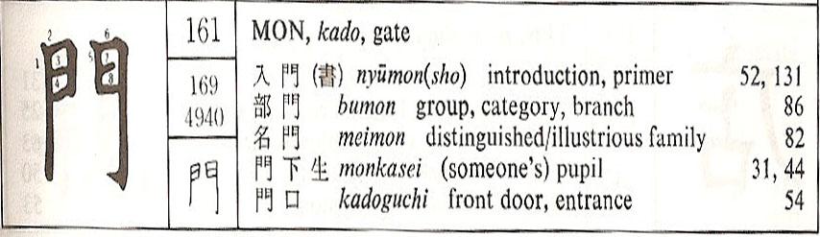

(Wolfgang Hadamitzky and Mark Spahn. Kanj & Kana.
Rutland and Tokyo: Charles E. Tuttle, 1981. [93].)

We can suggest reflecting on the meaning of doors and the implied connotations of representation of doors. Doors can be many things: a band, gates, gateways, openings on the environment, protection of the private…
Let us not assume limits of meaning but a sense of pointers.
What’s in a name?
Nestlé
Pedchenko, Vitaly. 2009. History of the Nestlé Logo. Etizianohttp://www.etiziano.com/I_love_logo_design/history_of_the_nestle_logo.html
“Nestlé is one of the greatest companies in the world. It has a long history and very interesting logo. But do you know history of the Nestle logo? Have you ever seen old Nestle logos? This famous logo has long and very interesting story.
I have sent a letter to the Nestle Company. When they answered and sent me history of their logo I was delighted as an archaeologist which digged up a new dinosaur skeleton.
I am pleased to share the history of the Nestle Logo with you.
Special thanks to Nestlé for help

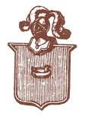 | The Nestlé logo was launched by Henri Nestlé in 1868 on the basis of the meaning of his name in German, i.e. little nest, and of his family emblem (that you can see here).
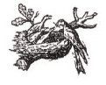 | Henri obtained a 15-year French patent for his logo in 1868.  After he retired, it was registered in Vevey in 1875 by the new owners of his company.
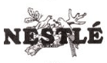 | In 1938, the traditional nest design was combined with the "Nestlé" name to form what is called the combined mark.
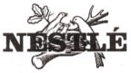 | In 1966 the design was simplified.
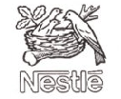 | In 1988, the worm in the mother bird's beak was removed and the fledglings became two instead of three. It is said that it was meant to better illustrate the activities of the company, no longer active only in nutrition, and to reflect the average modern family of two children.
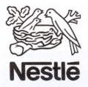 | The logo we know now [2009] has just been simplified.  The tree is supposed to represent an oak and the birds thrushes.
We see that this logo has its own life and story, it was changed many times to stay modern and have an up-to-date look. It may be a] good idea to update an old logo...rebranding to update communication (Pedchenko, 2009)
Pegasus

What is the relevance of « Petroleum Gas US ?
IBM and Apple

Can we detect a strategy to reverse symbols such as monochrome to “rainbow”, “straight” line versus rounded, Egyptian {font) versus Judeo Christian (apple).
What are Mythologies?

What’s in a text?
Introducing segmental analysis: the Waterman Pen.
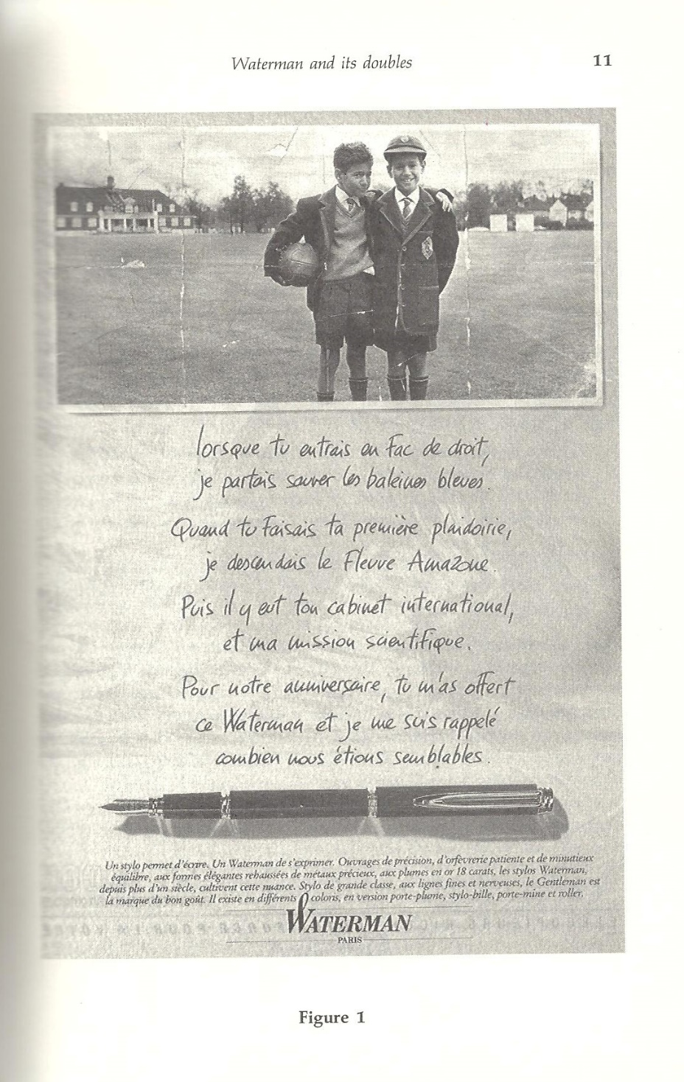

“When analysing a written text, a picture, or any other cultural object/event — for example riding on the subway or using a particular tool (as we will see later with the Opinel knife) — the semiotician’s purpose is, first, to consider it as a whole and then to proceed with a segmental analysis of it, an analysis of the units that compose it (Floch, 2000).”
How many segments can we identify in the Waterman Pen advertisement?
The story of the IBM-Apple invariance.
IBM v Apple
Blue | Rainbow (jumbled)
Singularity | Multiplicity
Square | Round
Stone | Fruit
Whole | Partial
New York | California
Conformity | Anarchy
Company | Individual
Power | Pleasure
We know | I'm curious

Method: Binary Opposition.

The position of the reader: a comparison between Velasquez, Vermeer, and Van Eyck.
Diego Velasquez. Las Meninas. In Sister Wendy Beckett. The Story of Painting: The Essential Guide to the History of Western Art. Surrey Hills: Dowling Kinderley – RD, 1995. [194].
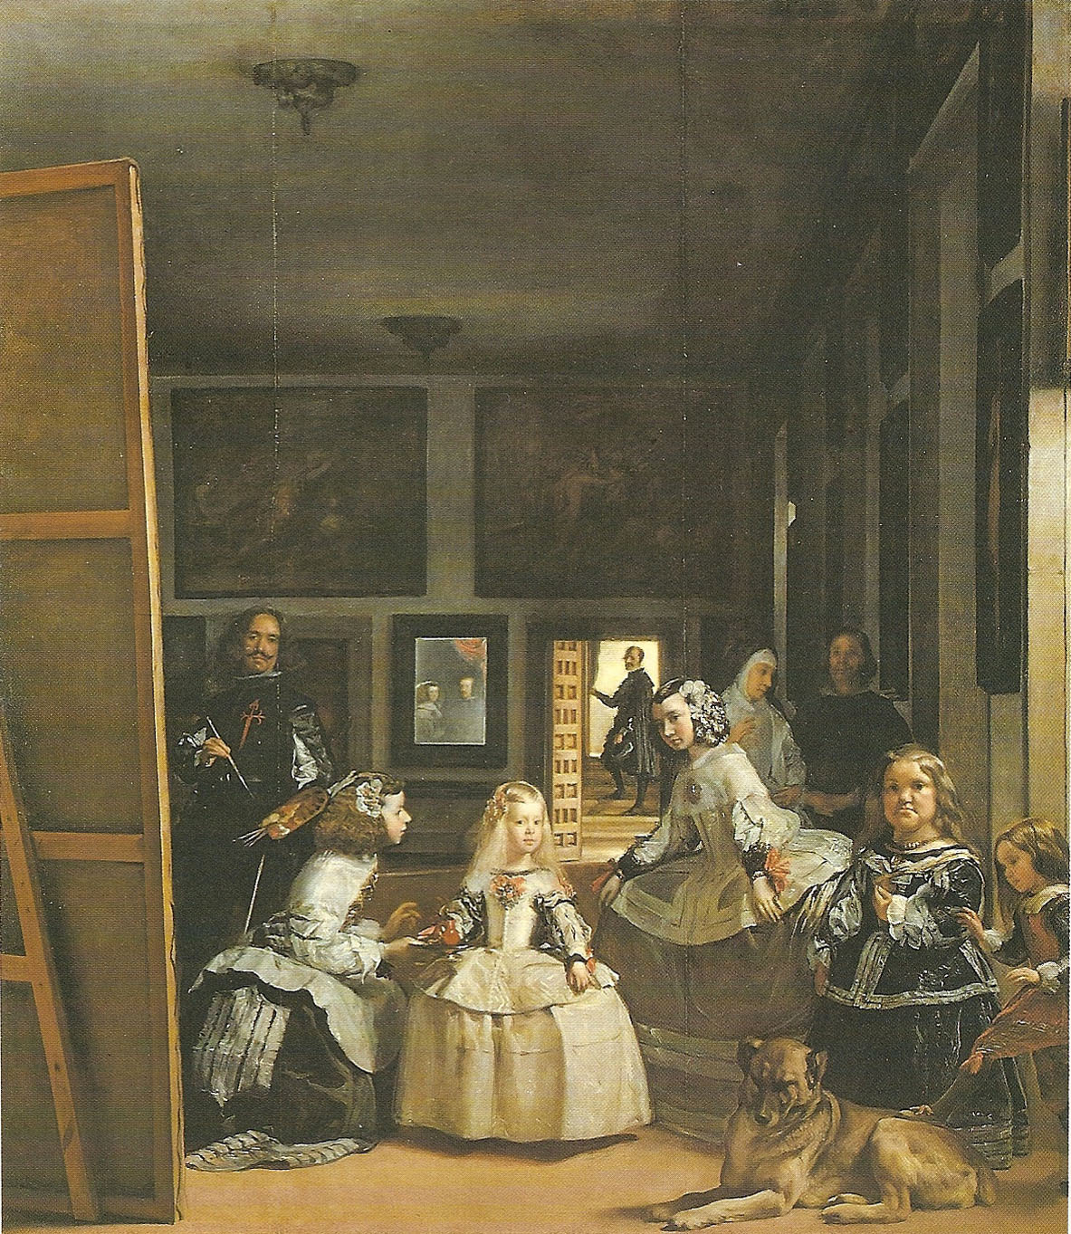

Who does the painter look at? Who is the subject of the pianting? Is the reader the topic?

Johannes Vermeer. The Painter in his Studio [Allegory of Painting]. In Nicola Hodge and Libby Anson. The A-Z of Art: The world’s greatest and most popular artists and their works. Carlton, 2002. [371].
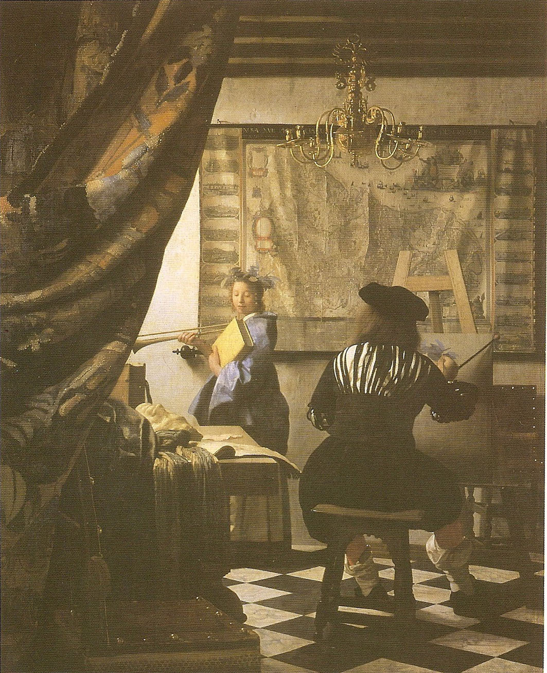

Who lifts the veil on a scene of a painter and a model? Who is watching? Is the reader a voyeur?

Jan van Eyck. The Arnolfini Marriage. In Nicola Hodge and Libby Anson. The A-Z of Art: The world’s greatest and most popular artists and their works. Carlton, 2002. [128].
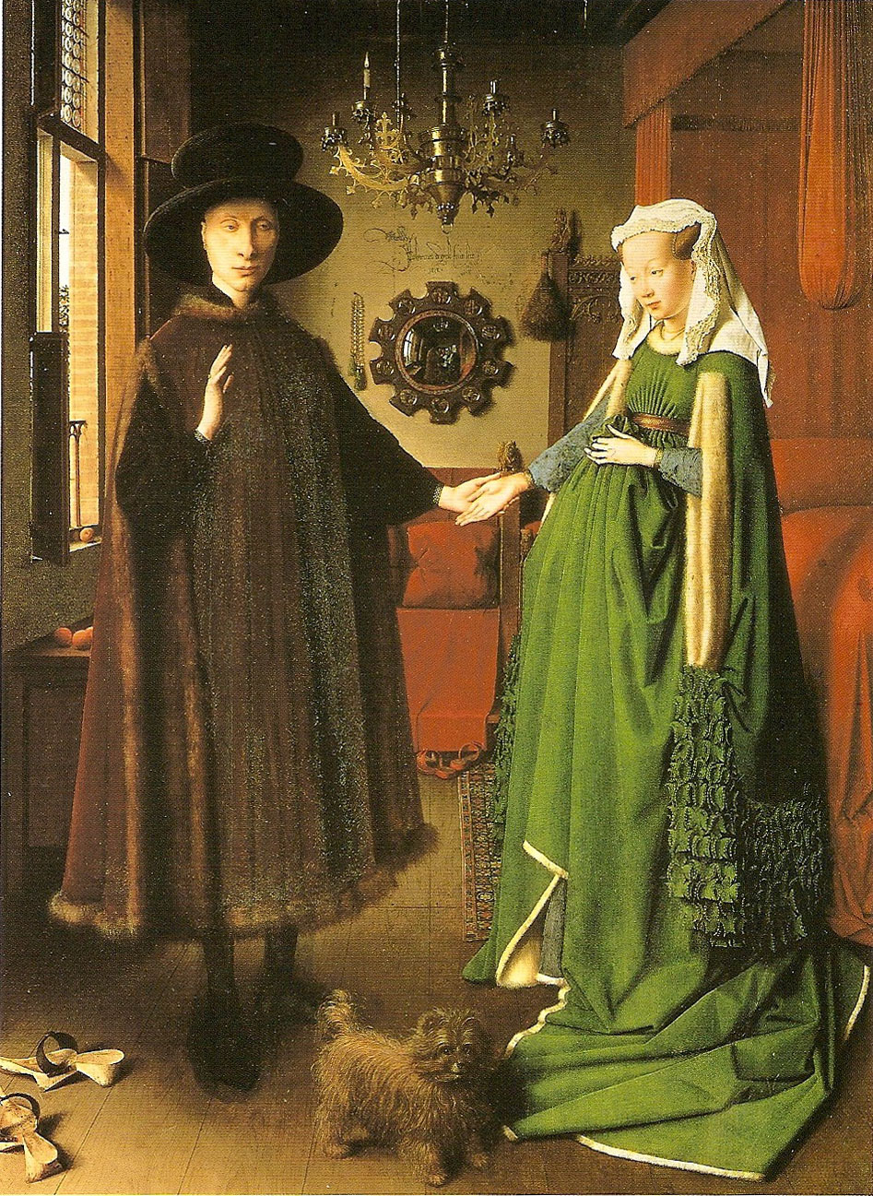

There are two people portrayed in the little round mirror. One of them is the painter, but who is the other person who can then testify to the wedding of these people? Is the reader a witness?
What is the relevance of axiological analysis?
The set and the goods.
Type and Token
We will start with a bit of theory, as an example.
We can lay out on the table five coins such as 2 “5 cent”, 2 “10 cent”, and 1 “20 cent”. We have thus 3 types (“5 cent”, “10 cent”, and “20 cent”) but 5 tokens (2 + 2 + 1). But let us add to the coins 2 “1 Dollar” notes and 1 “2 Dollar” note. We could say that we have 5 types (“5 cent”, “10 cent”, “20 cent”, “1 Dollar”, and “2 Dollar”) and 8 tokens (2 + 2 + 1 + 2 + 1). However we could also say that we have 2 types (coins and notes) and 8 tokens (5 + 3), or 1 type (currency) and 8 tokens (8), or more than five types because, at close inspection, there may be 2 different types in one of the types with two tokens (for instance: one of the 10c coins can have a different design; a special issue “for instance”). Classification in types is relative to the interpretive need of the moment while the total of 8 tokens remains. We could say that we just demonstrated that the same signs could deliver multiple interpretations according to how we value them.
Synaesthesia
Captain Beefheart & His Magic Band. Strictly Personal. CD. EMI 7243 8 29654 2 8, 1994.
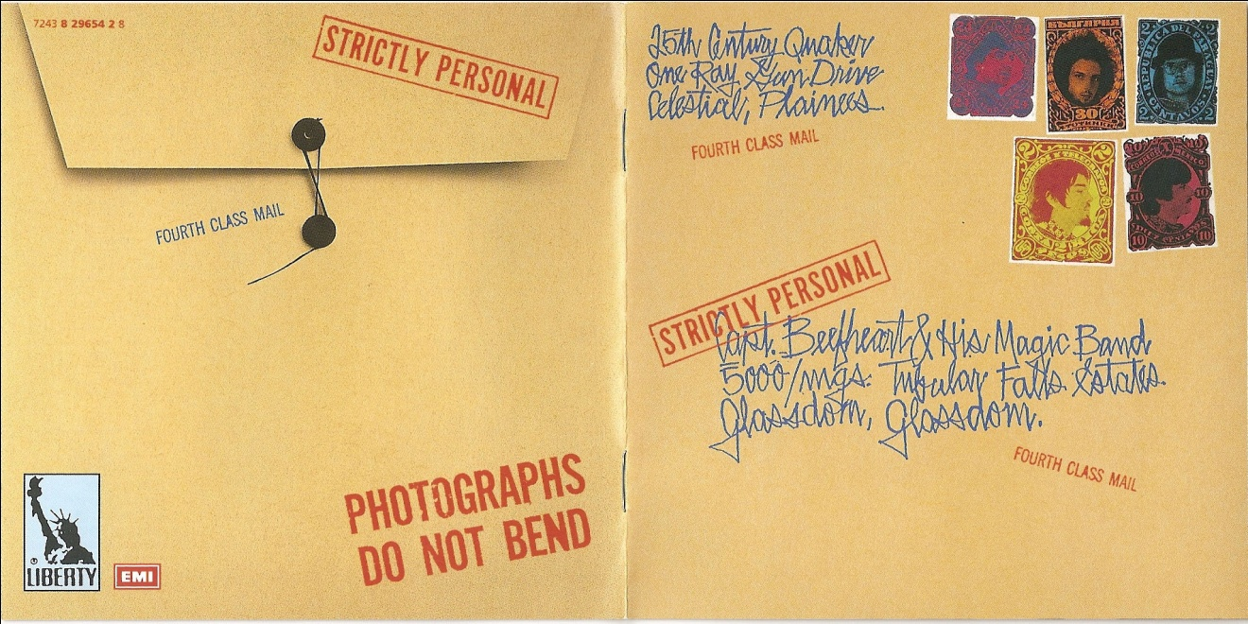

Let us imagine the music on a CD with the above cover. What could we expect? Is it likely to be western classical, or country, or Japanese koto, or…?
Find a recording of Captain Beefheart and compare the signs? Is there a form of synaesthesia?

The territory and the map.
- P. Van Osselaer. “Leeming”. Aerial photograph. PVO_P_Pic_Aero_MonMia_20050122_P.
- 2003 Perth Street Directory - 45th Edition. UBD. 2003. 348.
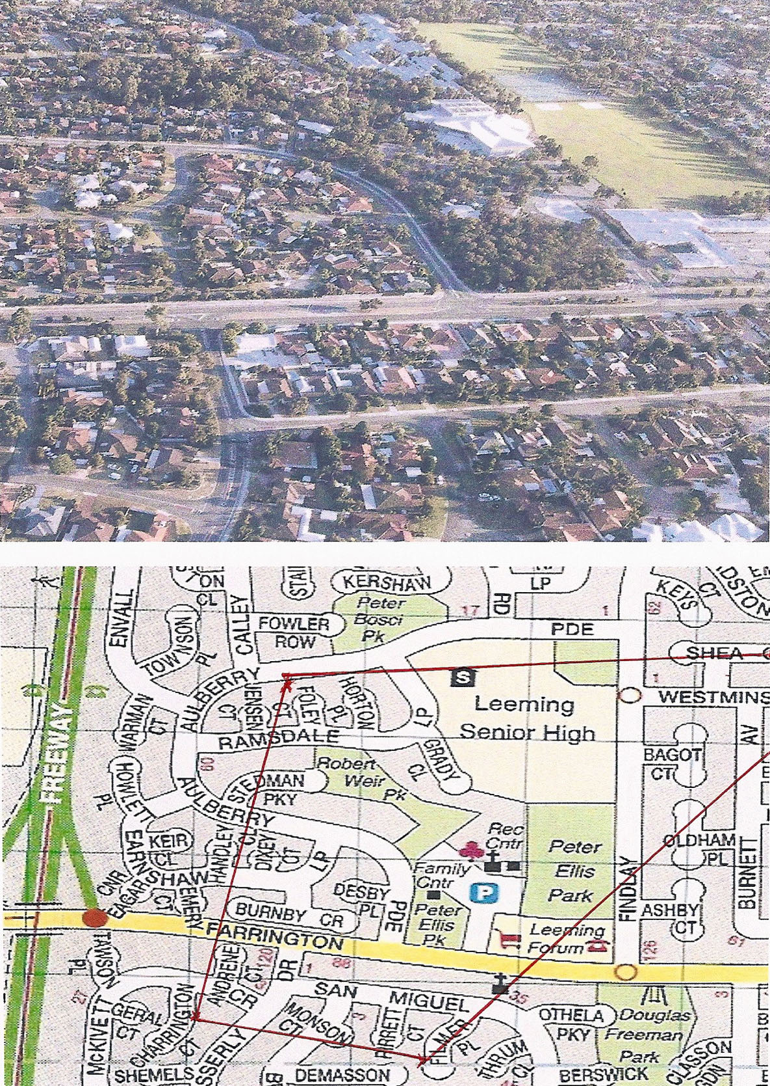

On the bottom picture, the red line indicates the area visible in the photograph, almost. The ‘mapping’ is not congruent. Neither of the ‘maps’ would be congruent with the territory… but represent it as a means to find a way, maybe.

Product line and integration: Opinel versus Swizz Army Knife.

http://www.opinel-usa.com/categories.asp
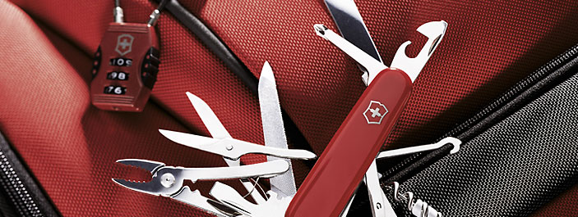

http://www.victorinox.com/ch/category/Category/The-Original-Swiss-Army- Knives/1000?f=category&v=1/100/1000&m=add&
“… Opinel is [not] a Swiss Army Knife (Fig. 3). And we can therefore readily observe that [their] qualities both condition and represent a specific use of the folding knife. I therefore believe it legitimate to imagine that the handle of a knife in fact extends into a certain way of doing things, one that ultimately speaks to a certain way of life or way of being. {We] are led to an analysis of the relationship between the form and the function of the knife. Moreover, we are trying to identify, if not a culture (perhaps an excessive word in this instance), then at least a way of thinking and a particular mode of interaction between self and world.” (Floch, 2000)
Let us then reflect on how we covey a worldview through what we design.

Brand involves belonging.
Let us check out some impersonations of the Mercedes logo.
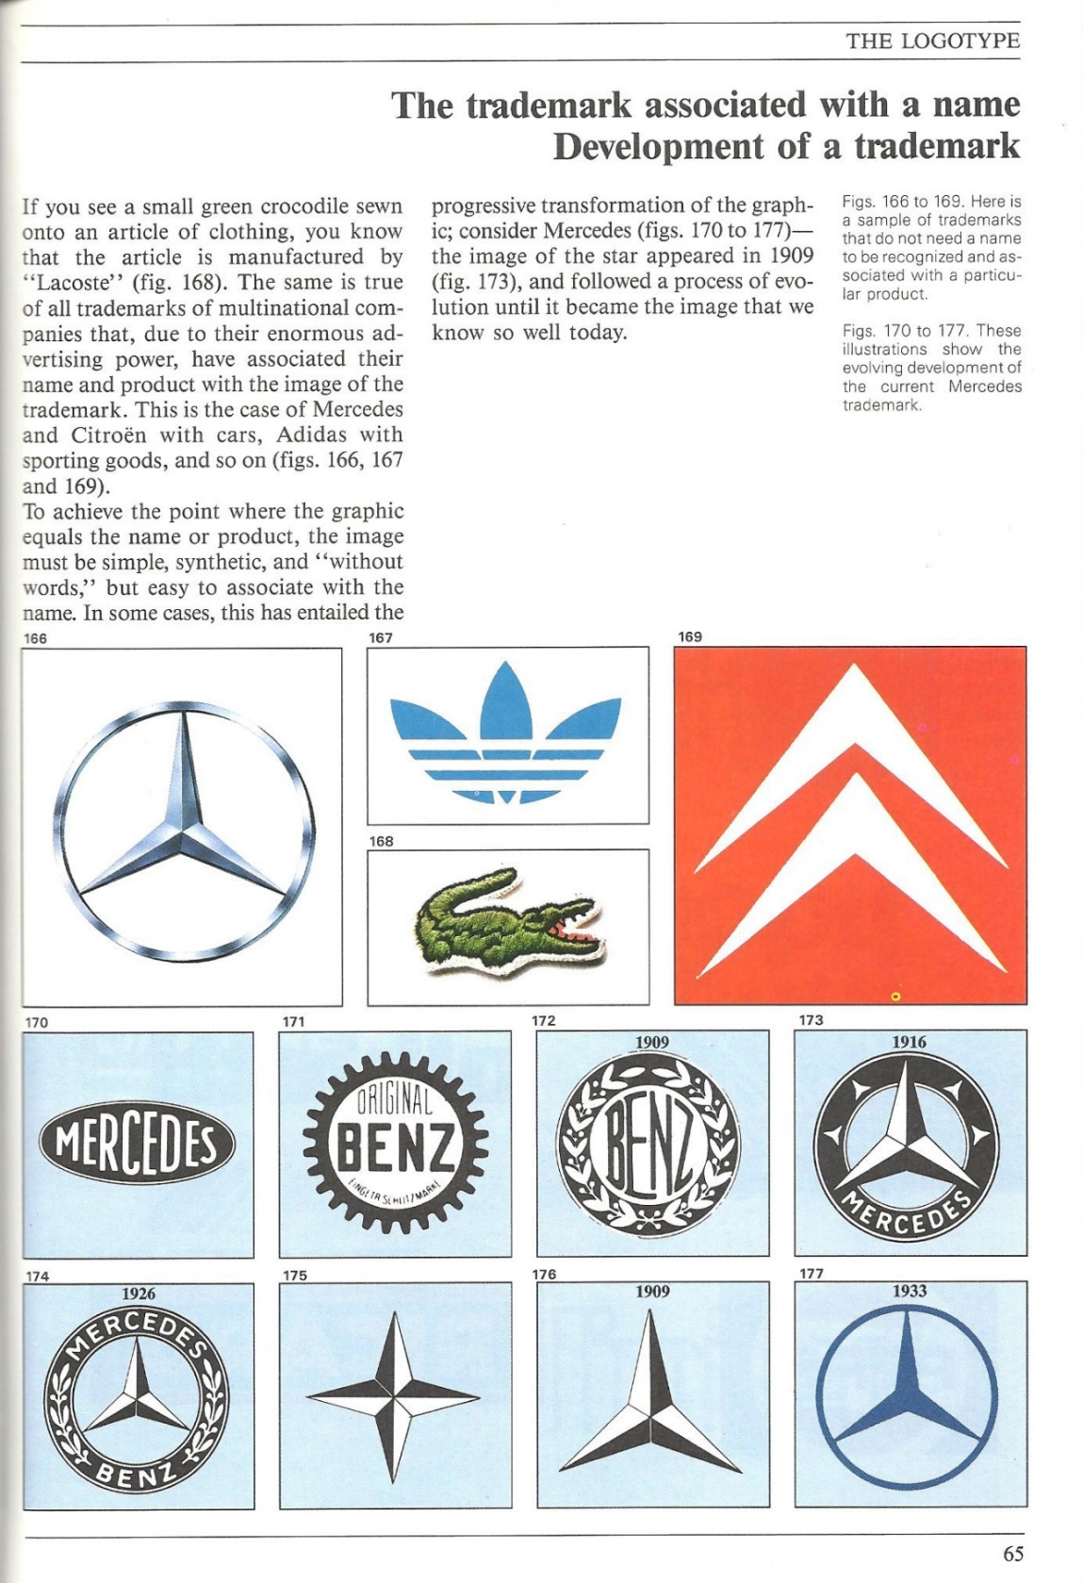

Parramon, Jose M. 1991. Lettering & Logotypes. New York: Watson-Guptill.
Let us then also note that these Mercedes logos cannot be confused with any of the other three (Adidas, Lacoste, Citroen).

Absolut is a case of “invariance”, it sets a recognisable visual type.
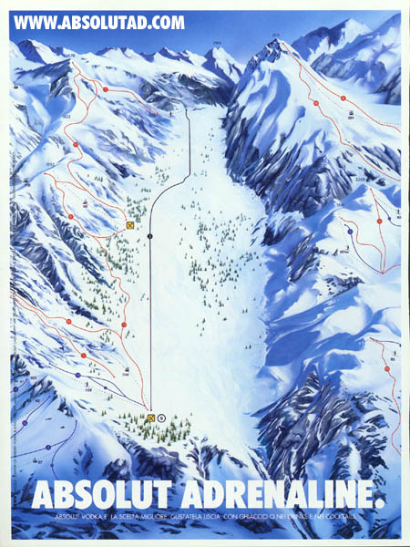
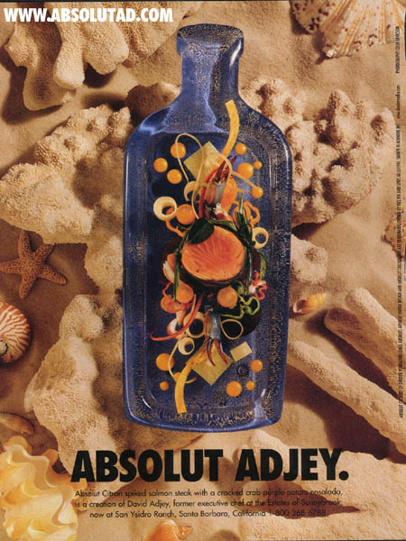

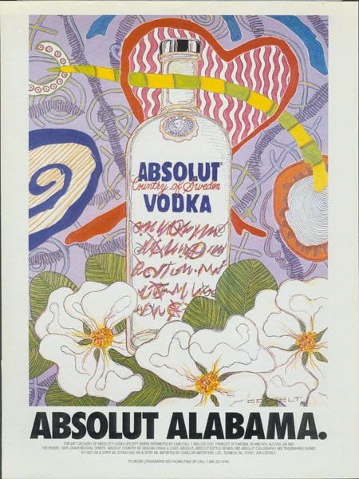
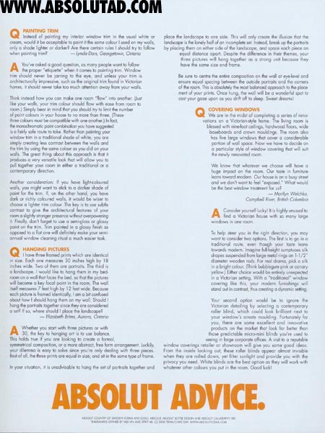

http://www.absolutad.com/absolut_gallery/singles/pictures/?id=2123&_s=singles

Benetton is also a case of “invariance”, but it sets a recognisable ideological subversion type.
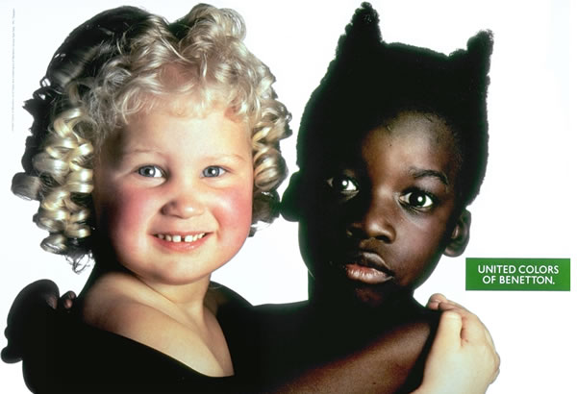

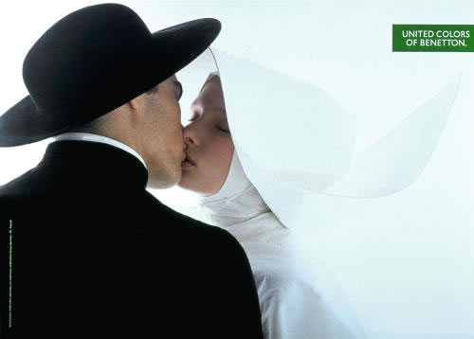

http://abduzeedo.com/awesome-and-controversial-ads-benetton

Design for a Target
Coco Chanel et Claude Poiret: the classical versus the baroque.
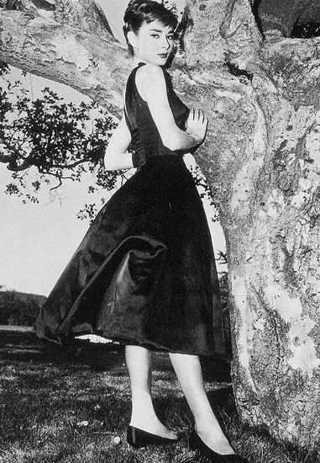

http://www.vintagetextile.com/little_black_dress.htm
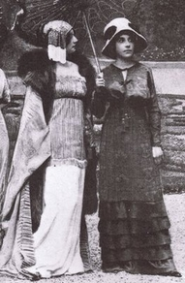

http://pinterest.com/pin/261842165804820997/

IKEA
- Governing the client.
- Demographics and the changing client.
- How do I see you see me?
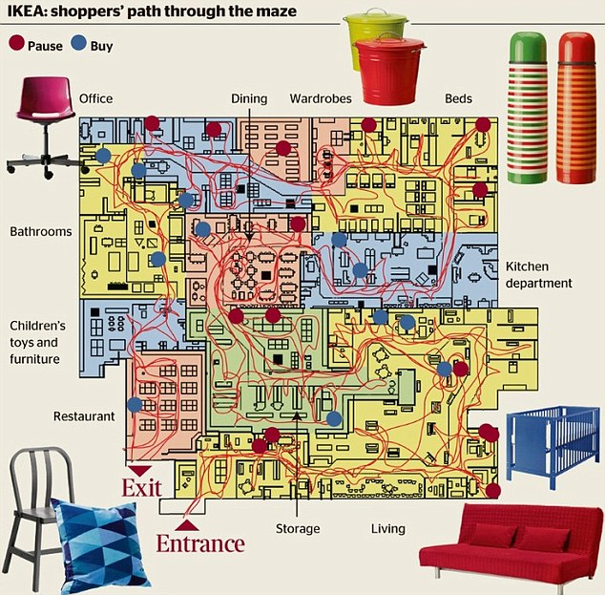

Cause and effect.
Causality is critical. What are the goals?
Questions?

Recommended readings:
Chandler, Daniel. 2005. Semiotics for Beginners. http://www.aber.ac.uk/media/Documents/S4B/sem01.html
Floch, Jean-Marie. 2000. Visual Identities. Trans. Pierre Van Osselaer and Alec McHoul. London and New York: Continuum.

